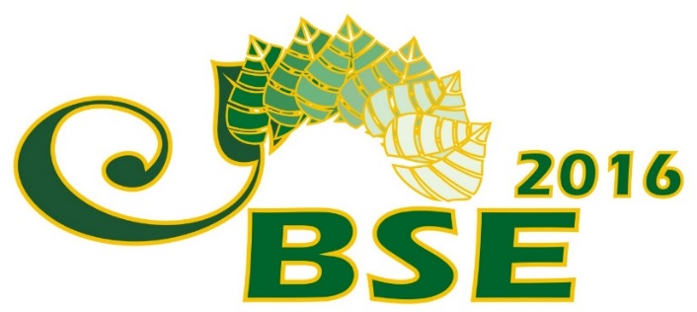
- Abstract
Submission
Form

Presenting Author(s)
 | (Mr, Mrs, Ms), First name, Surname:
Position, Scientific Degree:
 | (Prof. PhD, MD, MSc, etc.)
Organization/Department:
Mailing address:
e- mail of the presenting author(s):
Telephone (with country code): | + (…)
Preferred Participation type:
 | (oral presentation, poster, participant only)
Co-authors, their e-mails and affiliations:
Relevant Topic of the Conference:
Presentation title:
Abstract (up to 500 words);

Possible Reviewers, their e-mails and affiliations
Please send filled form to: timo.kikas@emu.ee

